# 

***Frontier Artists: Introduction***

**Level Design Document**

Written by: *Jacob Janezic Joshua Boyd*

Version: *version ## here*

Date: *date of this current version*



Your logo goes here

Copyright 2018 *your name goes here*. All Rights Reserved.

Do not Duplicate or Distribute without the express permission of the copyright holder.

This document is considered to be CONFIDENTIAL and PRIVATE.

# TABLE OF CONTENTS

**TABLE OF CONTENTS 2**

**version HISTORY 3**

01.00.00 3

**Introduction 4**

WORLD DIAGRAM 4

OVERVIEW OF LEVEL DESIGN (NAME OF LEVEL) 4

LEVEL DESIGN DIAGRAM 4

Mission DESIGN List 4

**ACCESSIBLITY & Use 4**

INCLUSION 4

GAME REQUIREMENTS 5

USER CHARACTERISTICS 5

USER OBJECTIVES 5

USE CASE DIAGRAM 5

USE CASE NARRATIVE (NAME OF USE CASE HERE) 6

**STORY ARCHITECTURE 6**

STORY STRUCTURE 6

STORY TYPE 6

STORY THROUGHLINES 6

SCRIPT MANAGEMENT 6

**VISUAL ARCHITECTURE 6**

AESTHETICS 7

COLOR THEORY 7

TYPOGRAPHY 7

BUTTON MAP 7

USER INTERFACE 7

NAVIGATION HIERARCHY 7

*Screen [x.1] 7*

*Screen [x.2] 7*

*Screen [x.3] 7*

ENVIRONMENT DESIGN 8

VISUAL CHARACTER DESIGN (CHARACTER NAME) 8

**sonic ARCHITECTURE 8**

SOUND EFFECTS: STINGERS 8

SOUND EFFECTS: TAGS 8

MUSIC: INTRO 8

MUSIC: LOOP 8

MUSIC: TRANSITION 8

**SOFTWARE gameplay ARCHITECTURE 9**

LOGICAL VIEW 9

DATA VIEW 9

LOCALIZATION 9

INSTRUMENTATION VIEW 9

SECURITY VIEW 10

# version HISTORY

*This section contains a listing of each version of your design document. Every time you open your document save it off as a different file and record what you worked on or changed here.*

*About version numbers:*

*XX.YY.ZZ format*

*XX – major revisions, new sections, complete section revisions*

*YY – revisions to existing sections, major and minor*

*ZZ – small corrections, typos, grammar, formatting, etc.*

## 01.00.00

*Added*:

***Accessibility and Use***

*Inclusion*

*INCLUSION*

*GAME REQUIREMENTS*

*USER CHARACTERISTICS*

*USER OBJECTIVES*

*USE CASE DIAGRAM*

*Put the sections added to here.*

# Introduction

*The level design documents ensure the communication of the design leads so that the overall integrity of the game is preserved. There is a separate document for every level. The lead level designer is the owner of the document. The lead visual designer is the owner of the visual architecture section. The lead sound composer is the owner of the sonic architecture section. The level tech lead is the owner of the software architecture section of this document. Generally, this and other documentation will be in a source control database to keep the integrity of the document intact. If a source control is not available for the team, then make a note here as to how the document will be shared and managed by the level lead.*

## WORLD DIAGRAM

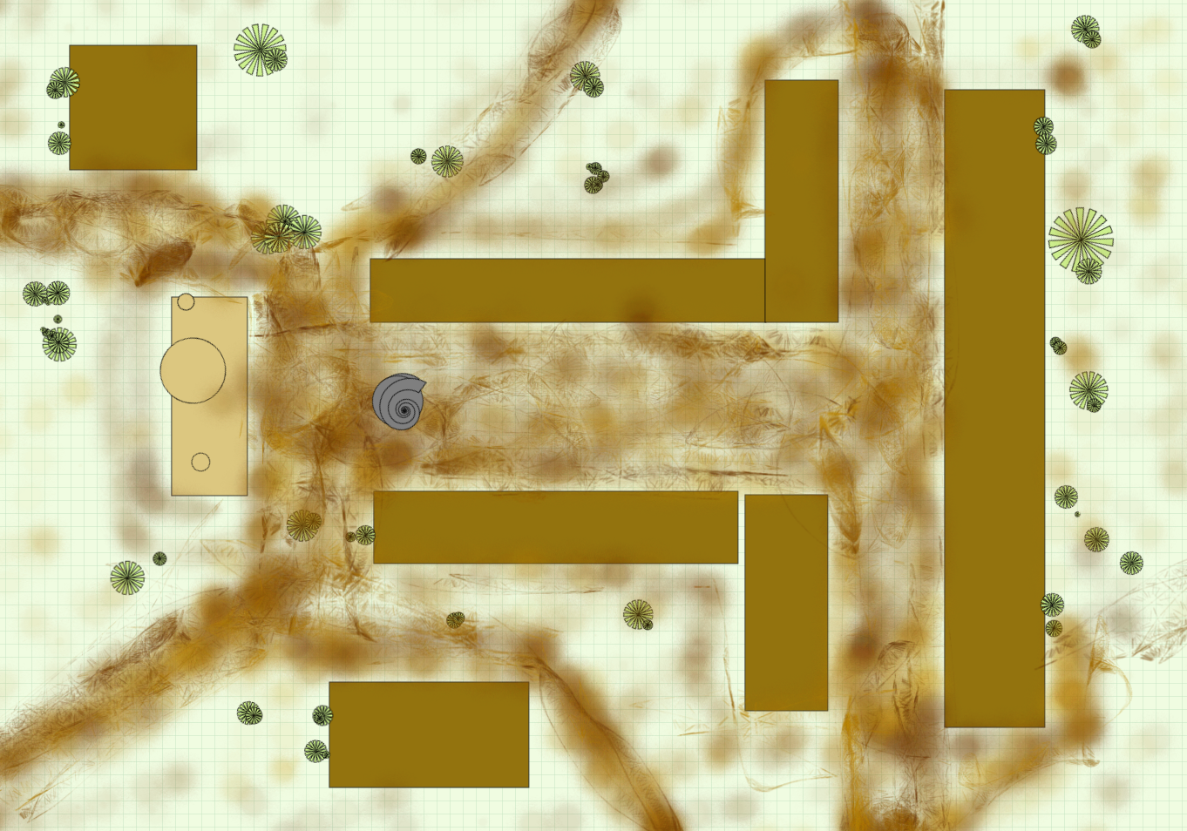

## OVERVIEW OF LEVEL DESIGN (Statue Town)

*This is from the Game Design Document.*

|  |  |  |
| --- | --- | --- |
| Level 1: Statue Town  Plot Point: Gather the Statue Pieces, shape and refine them into the statue. | **Goal: Restore the Statue to its artist’s vision.**  Rules: Gather the Statue chunks in the center and re-create the statue.  Mechanic: Statue parts carried by the player back to the center will only stay for a limited amount of time. If 8 parts are in the center concurrently, a block of marble will form and persist until the player(s) chisel and restore the statue within. The Statue will then remain visible for a set amount of time before resetting. | **Challenge: Statue parts need to be collected in the middle in quick succession before they disappear and reset.**  Strategy: The more familiarity the player(s) gain with the map, the quicker they can get the pieces to the center.  Tactics: Having more players does not increase the difficulty, encouraging cooperation with others. |

*.*

## LEVEL DESIGN DIAGRAM

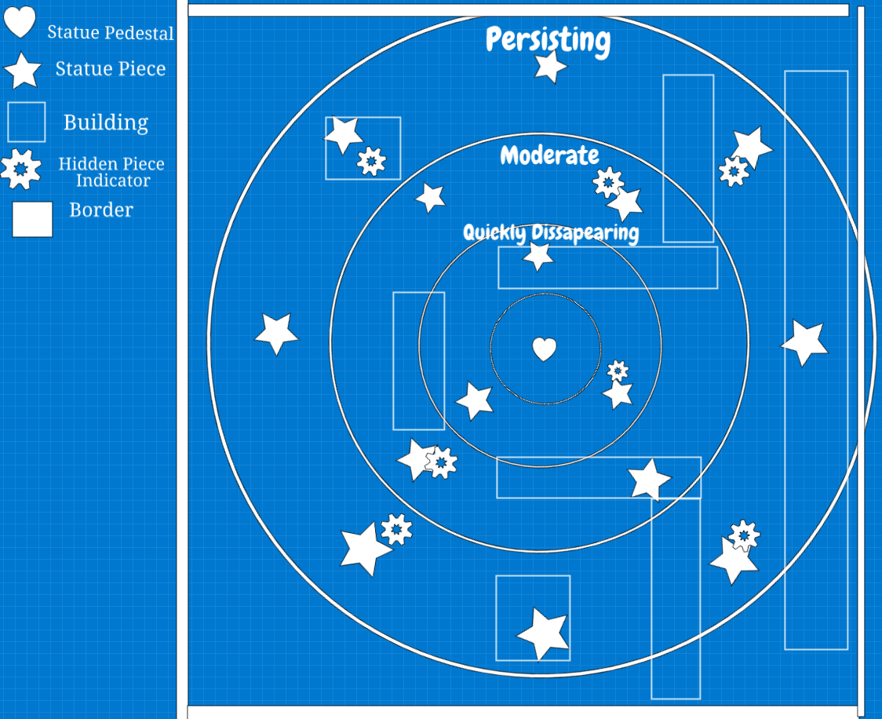

## Mission DESIGN List

*The mission design list gives you a place to link all of your mission designs for this level. Add lines to this table as needed.*

|  |  |
| --- | --- |
| Name of Mission | Name of Mission Design Document |
| Collect Pieces | Gathering Parts |
| Chisel Statue | Destruction Tools |
| Restore Statue | Reconstruction Tools |

# ACCESSIBILITY & Use

*From the Game Design Document.*

*According to these guidelines:* [*http://gameaccessibilityguidelines.com*](http://gameaccessibilityguidelines.com) *how will your game be made accessible to the greatest number of abilities? Write the goals for accessibility the general inclusion strategies here.*

## INCLUSION

|  |  |  |
| --- | --- | --- |
| Ability | Level (Basic, Intermediate, Advanced) | Strategy for inclusion |
| *Fine Motor* | *Basic* | *Simple controls* |
| *Large Motor* | *Intermediate* | *Not reliant on motion tracking, no button mashing or quick-time required.* |
| *Cognitive* | *Intermediate* | *Contextual In-game tips* |
| *Vision* | *Basic* | *Easily readable font, not VR,* |
| *Hearing* | *Basic* | *Captions or subtitles included* |
| *Speech* | *Basic* | *Not required* |
| *General* | *Basic* | *Easy, basic difficulty level* |

## GAME REQUIREMENTS

*These are the requirements for the game that will become the traceability matrix and will help the team communicate who are working on the game, there is a scoping meeting with the team to determine which requirements will be built and which will be in the next release or iteration of the project. Add a row for each requirement to this table.*

|  |  |  |  |  |
| --- | --- | --- | --- | --- |
| Done  (Y/N) | # | Requirement Description | Originator of Req. | Scope (In/Out) |
|  | 1 | The player can start the game |  |  |
|  | 2 | The player can move throughout the level |  |  |
|  | 3 | The player can pick up artifacts |  |  |
|  | 4 | The player can place them on the pedestal |  |  |
|  | 5 | The player can read and close the placard |  |  |
|  | 6 | The player can have fun |  |  |

## USER CHARACTERISTICS

*Users are anyone who interacts with the game in some way. Some examples have been filled in to guide you. Delete or add as needed.*

|  |  |  |
| --- | --- | --- |
| How many? | Title | Description of Characteristics |
| 4 max | Casual players | Some of them are part time (easily distracted by shiny things). These players are able to explore the functionality of the game and progress towards the completion of the statues. |
|  | Moderators | They manage the game within the game while players are playing if they encounter any issues. They provide live feedback and quality assurance. |

## 

## USER OBJECTIVES

|  |  |  |
| --- | --- | --- |
| Title | Description of Objectives | Workflow |
| Casual player | Assemble statues, learn background information, have fun. | Explore the world, find artifacts, assemble statues, acquire knowledge. |
| Moderators | Ensure the functionality of the game and provide assistance to progress when necessary. | Mostly passive interaction with the players and problem-solving when necessary. |

## USE CASE DIAGRAM

*There will be a use case narrative for each of the identified use cases in this diagram for the level. The identified users are the actors in this diagram.*

**

## USE CASE NARRATIVE

|  |  |
| --- | --- |
| ***Details of the use case actors*** | |
| *Use Case Name:* | Encounter bugs |
| *Primary Actors:* | Player |
| *Secondary Actors:* | Moderator |

*Purpose:*

This use case occurs when the player encounters a technical glitch or bug in the game experience.

*Trigger:*

When something goes wrong.

*Pre-conditions:*

There is no problem prior and one arises.

*Basic Course:*

Trouble-shooting techniques

*Post-Conditions*:

The problem is resolved

*Possible Alternate Flows:*

End the game, try and start over to wipe and memory problems.

## 

|  |  |
| --- | --- |
| ***Details of the use case actors*** | |
| *Use Case Name:* | Search for artifacts |
| *Primary Actors:* | Player |
| *Secondary Actors:* | N/A |

*Purpose:*

This use case occurs when the player has become familiar with the controls and is ready to begin the game

*Trigger:*

The player is required to exit the control panel to unlock movement.

*Pre-conditions:*

The player has just started the game and has not closed the control screen.

*Basic Course:*

The player will explore the level’s environment looking for interactables.

*Post-Conditions*:

The player will be able to connect the various pieces together to form statues. This in turn provides additional information about the statues and creates a sensation of discovery and fun as a byproduct.

*Possible Alternate Flows:*

The player does not understand the goal and makes no further progress in the game.

# STORY ARCHITECTURE

## STORY STRUCTURE

*An old abandoned town with historical value, forgotten to time. The players seek to restore a time period in order to appreciate art. As the statue becomes revealed, history is being created in the players hands, and being unearthed simultaneously.*

## STORY TYPE

*Rebirth*

## STORY THROUGHLINES

*Main Character: Seeking broken pieces, through teamwork restores and breathes new life to Statue.  
Influence: Realises through finding the parts that cooperation pushes you further beyond your own potential.  
Relationship: Working as a team to bring together something broken, and unearth what is beneath the surface by working with one another.*

*Objective: Participants of the town realize the importance of the statue and come together to restore it to its original state.*

## SCRIPT MANAGEMENT

*The town is desolate, abandoned. It can become historically remembered. A great work has been forgotten and destroyed. Cooperation can bring it back. What's underneath the surface is more beautiful than the broken pieces. Togetherness accomplishes better feats then aloneness.*

**Yuan Huang**

# VISUAL ARCHITECTURE

*The general direction was set in the Game Design Document. In this document concept drawings are developed, assets are created, and storyboards for gameplay are created.*

## AESTHETICS

We're going to design a midwest visual style. The overall brightness of the environment will be dim, but the objects will emit weak light to highlight the main objects related to clues, such as parts of statues. We will choose warm colors to match the midwest style and give players a better visual experience. For color blind players, we will add player custom options in “Setting”. For example: Color reverse option (Palette option to change player perspective screen). Brightness adjustment （Light source sensitivity/ lighting will change based on player’s location).

## COLOR THEORY

We will choose a warm color as our game’s color tone. But the incomplete statue or parts of the statue will be black and white. Only when players collect all the pieces and put them together, the statue will restore its original color. I think it can strengthen both the concept and gameplay.

## TYPOGRAPHY

In some cases, subtitles at the bottom can be a better choice for commentary, but we can also choose a glowing font that appears in the center of the player's view without a lot of words to read. Based on the historical nature of the game, we can make some necessary text explanations appear on the kraft paper that players can find.

## 

## 

## 

## BUTTON MAP

## 

## 

## USER INTERFACE

We will have a mini map on the top of the left corner, a chat box on the bottom left corner, an icon for Settings on the top right corner and an item bar on the middle of the bottom.

## NAVIGATION HIERARCHY

1. After starting the game, players should see the game’s main menu with a list of options, which includes “Start Game”, “Continue”, “Settings”, and “Exit”. When players pass the game, they will see a new option called “Gallery” on the main menu screen. Players can check history and back stories of the statue that collected in game.

## ENVIRONMENT DESIGN

The game should take place in the old west.

## VISUAL CHARACTER DESIGN (CHARACTER NAME)

Players can do face recognition to create their own character or choose to use the default character models. Characters need animations for moving , collecting , taking , splicing, destroying , carving, and painting animation. Characters also need sounds for breathing while they are moving and carving. In order to include blind players, characters will make sounds (like ouch) when they hit on a wall or object (To let players know they have obstacles in front of them or have reached the boundaries of the room).

# sonic ARCHITECTURE

*The general direction was set in the Game Design Document. What software will you use to compose and record the sound and music? In this document the composition of the sonic environment and music for the game is addressed.* *Also – how will the game be accessible to the blind?*

The sonic component of the game will be compiled of sound effects created in Adobe Audition, Ableton Live 10 lite, and Audacity. Any samples will be Free Use and properly sourced if is not original creative work. Unfortunately, the game will not be quite accessible to the blind, however the atmosphere created may be able to provide some context to the setting.

*Watch this first:*

<https://youtu.be/q4CYUfgRdos> (Video Game Scoring Online Masterclass with [Chance Thomas](http://chancethomas.com/))

*If you are headed to be a composer for games – this book is a must:*

<https://www.amazon.com/Composing-Music-Games-Technology-Business/dp/1138021415>

*This is good information as well:*

<https://www.npr.org/templates/story/story.php?storyId=89565567>

<https://kotaku.com/the-best-video-game-music-of-2017-1821534087>

<https://midnightmusic.com.au/2016/06/the-guide-to-composing-music-for-video-games/>

## SOUND EFFECTS: STINGERS

*These happen when there is an event in the game. On collision, etc.*

[*http://creativeskillset.org/job_roles/3844_foley_editor*](http://creativeskillset.org/job_roles/3844_foley_editor)

Menu close

Footsteps

Artifact pick up

Artifact collision

Artifact place

Tool pick up

Tool use

## SOUND EFFECTS: TAGS

*These happen at the end of a level or a game.*

[*http://creativeskillset.org/job_roles/3844_foley_editor*](http://creativeskillset.org/job_roles/3844_foley_editor)

Western melody

## MUSIC: INTRO

*Sets the mood for the gameplay that’s about to occur. Also sets the musical palette for the game soundtrack.*

Mild ambient music. This will be calm but have western tones or influences. Maybe some cowboy music.

## MUSIC: LOOP

*“The workhorse of the gaming industry”. A short, repeatable section of music which can be played over and over until the gameplay changes or the character dies (!)*

Ambient background loop

Menu music

Campsite music

## MUSIC: TRANSITION

*Connecting music (i.e. music that accompanies a cut scene that aims to maintain the player’s interest)*

# SOFTWARE gameplay ARCHITECTURE

## LOGICAL VIEW

The essential classes we will need to use will include:

* A Player class, an **entity** that gives players a method of input and influence over the game.
* An Item class, an **entity** that can be physically carried. Certain events can only be triggered while carrying these items, or after they have been placed in a designated spot/area.
* A Trigger class, an **entity** with or without a physical presence in the game used to change camera angle, music, and to facilitate puzzles.
* A Minigame class, an **event** that allows players to compete against each other. This may also be used to facilitate certain puzzles.

At the moment we have no working design patterns or Class diagrams, however due to the simplicity of the game it is not hard to foresee the need for a relatively small or simple design pattern for the purpose of tracking what categories of entities exist. There are not that many components to this level, so whichever pattern we do end up choosing would likely end up easily read.

## DATA VIEW

The only recordable data we will need is a method to record how many players are in the game at any given time and variables related to each player. CORE handles multiplayer experiences, so there is likely a method to handle this without the need to create a specialized database. Since this level will have exactly one permutation and does not change, we will have no need for procedural generation or excessive use of random number generation.

## LOCALIZATION

The readable text in this game is mostly descriptive and will likely not take a major effort to localize into other languages. The most text-heavy cases would be descriptions of minigames

## INSTRUMENTATION VIEW

We will utilize Code Tracing as a method to debug the code of the game, as well as a data log to determine when an exception occurs in relation to major or noticeable events. We are utilizing the Engine, not developing it, so we must work with what we have in order to alleviate problems from our game’s overall structure.

## SECURITY VIEW

This level, as well as the overall game, will be using the CORE engine. CORE provides an inline client to host servers for this level, so we are not responsible for security implementation.